
The Holy Eucharist
The [second … Seventh] sunday in Easter
Sunday, Month 00, 2026 at 00:00 am
Welcome to the Cathedral Church of the Anglican Diocese of British Columbia.
We respectfully acknowledge that we gather to worship on the ancestral lands
of the Esquimalt and Songhees Nations, with whom we are in relationship to seek reconciliation.
This service is being broadcast live on the internet.
By attending, you acknowledge and consent to the fact that video images of you may appear there.
Today’s service (“the liturgy”) is the work of the whole People of God, and all are encouraged to speak the responses in bold and sing the hymns, found in the blue Common Praise hymnal.

The Gathering
Organ Voluntary | Chaconne in g minor BWV 1179 | Citation

Land Acknowledgement and Welcome
The people stand as the procession enters.

Choral Introit | Citation

Hymn 000 | Citation

Dominical Greeting
The grace of our Lord Jesus Christ, and the love of God, and the fellowship of the Holy Spirit, be with you all.
And also with you.

Seasonal Greeting
Alleluia! Christ is risen.
Christ is risen indeed. Alleluia!.

Collect for Purity
Almighty God,
to you all hearts are open, all desires known,
and from you no secrets are hidden:
cleanse the thoughts of our hearts
by the inspiration of your Holy Spirit,
that we may perfectly love you,
and worthily magnify your holy name;
through Christ our Lord. Amen.
Gloria in Excelsis | David Thorne
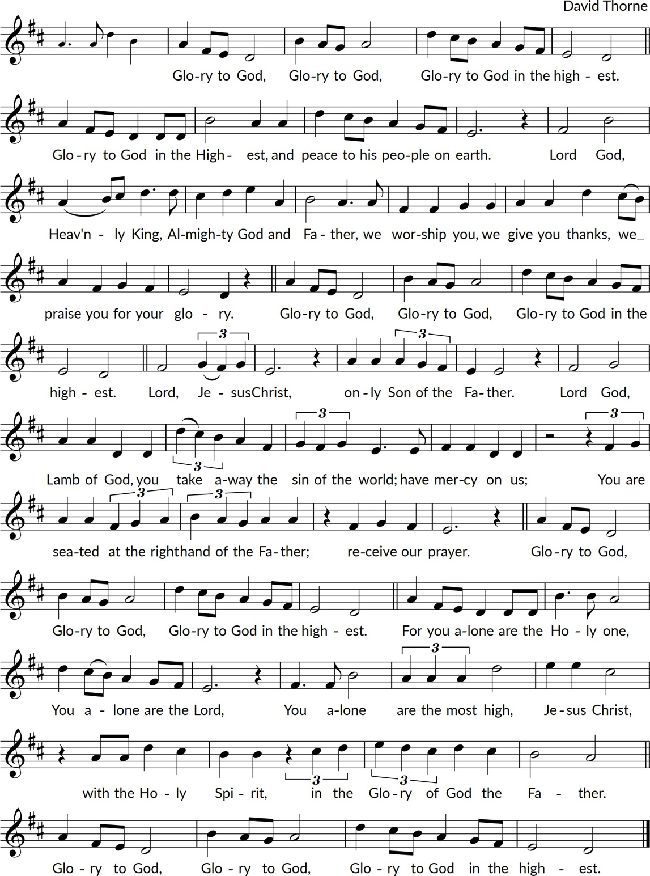

Gloria in Excelsis | Citation
Sung by the choir, in Latin.

Glória in excélsis Deo et in terra pax homínibus bonae voluntátis.
Laudámus te,benedícimus te,
adorámus te, glorificámus te,
grátias ágimus tibi propter
magnam glóriam tuam,
Dómine Deus, Rex cæléstis,
Deus Pater omnípotens.
Dómine Fili Unigénite, Iesu Christe,
Dómine Deus, Agnus Dei,
Fílius Patris,
qui tollis peccáta mundi,
miserére nobis;
qui tollis peccáta mundi,
súscipe deprecatiónem nostram.
Qui sedes ad déxteram Patris, miserére nobis.
Quóniam tu solus Sanctus,
tu solus Dóminus,
tu solus Altíssimus,
Iesu Christe,
cum Sancto Spíritu:
in glória Dei Patris. Amen.
Glory to God in the highest, and on earth
peace to people of good will.
We praise you, we bless you,
we adore you, we glorify you,
we give you thanks on account of
your great glory.
Lord God, heavenly king,
Almighty God and Father,
Lord Jesus Christ, only Son of the Father,
Lord God, Lamb of God,
Son of the Father,
who takes away the sin of the world:
have mercy on us;
who takes away the sin of the world,
hear our prayers;.
you who are seated at the right hand of the Father, have mercy on us:
For you alone are Holy,
you alone are the Lord,
you alone are the Most High,
Jesus Christ,
with the Holy Spirit,
in the glory of God the Father. Amen.

Gloria in Excelsis | Citation
Sung by the choir.
Glory be to God on high, and in earth peace, good will towards men. We praise thee, we bless thee, we worship thee, we glorify thee, we give thanks to thee for thy great glory, O Lord God, heavenly king, God the Father almighty. O Lord, the only-begotten Son, Jesus Christ; O Lord God, Lamb of God, Son of the Father, that takest away the sin of the world, have mercy upon us. Thou that takest away the sin of the world, receive our prayer. Thou that sittest at the right hand of God the Father, have mercy upon us. For thou only art holy; thou only art the Lord; thou only, O Christ, with the Holy Ghost, art most high in the glory of God the Father. Amen.

The Collect of the Day
Let us hold this moment open to God's grace.
Collect text.
Amen.
The people sit.

The Proclamation of the Word
The First Reading | Book 1:1-1
A reading from….
Reading text, if included.
The Word of the Lord.
Thanks be to God.

Psalm 000
The Second Reading | Book 1:1-1
A reading from….
Reading text, if included.
The Word of the Lord.
Thanks be to God.
Hymn 000 | Puer Nobis
That Easter day with joy was bright;
the sun shone out with fairer light
when, to their longing eyes restored,
the apostles saw their risen Lord!
O Jesus, king of gentleness,
with constant love our hearts possess;
to you our lips will ever raise
the tribute of our grateful praise.
O Christ, you are the Lord of all
in this our Easter festival,
for you will be our strength and shield
from ev'ry weapon death can wield.
All praise, O risen Lord, we give
to you, once dead, but now alive!
To God the Father equal praise,
and God the Spirit, now we raise!
Text: John Mason Neale, 1818-1866; Music: Michael Praetorius, 1571-1621
The Holy Gospel | Book 1:1-1
The people turn to face the Gospel as it is processed into the center aisle.
Before the Gospel
The Lord be with you.
And also with you.
The Holy Gospel of our Lord Jesus Christ, according to John.
Glory to you, Lord Jesus Christ.
The Gospel is proclaimed in the midst of the people, concluding:
The Gospel of Christ.
Praise to you, Lord Jesus Christ.
The people sit.
Sermon | Preacher Name
The people stand.

The Nicene Creed
We believe in one God,
the Father, the Almighty,
maker of heaven and earth,
of all that is, seen and unseen.
We believe in one Lord, Jesus Christ,
the only Son of God,
eternally begotten of the Father,
God from God, Light from Light,
true God from true God,
begotten, not made,
of one Being with the Father;
through him all things were made.
For us and for our salvation
he came down from heaven,
was incarnate of the Holy Spirit and the Virgin Mary
and became truly human.
For our sake he was crucified under Pontius Pilate;
he suffered death and was buried.
On the third day he rose again
in accordance with the Scriptures;
he ascended into heaven
and is seated at the right hand of the Father.
He will come again in glory to judge the living and the dead,
and his kingdom will have no end.
We believe in the Holy Spirit, the Lord, the giver of life,
who proceeds from the Father,
who with the Father and the Son is worshiped and glorified,
who has spoken through the prophets.
We believe in one holy catholic and apostolic Church.
We acknowledge one baptism for the forgiveness of sins.
We look for the resurrection of the dead,
and the life of the world to come. Amen.

The Prayers of the People
The people remain standing. Each bidding concludes
Risen Christ, we pray.
The people respond
Hear our prayer.
The Presider concludes the prayers with the following or another suitable collect:
God of glory, by the raising of your Son you have broken the chains of death: fill your church with faith and hope, for a new day has dawned and the way of life stands before us; through Jesus Christ, our risen Saviour.
Amen.

The Peace
The peace of Christ be always with you.
And also with you.
The people greet one another with a gesture of Christ’s peace, then take their seats for the announcements.

Announcements

The Celebration of the Eucharist

Offertory Sentence
Walk in love, as Christ loved us and gave himself for us, an offering and sacrifice to God.
Ephesians 5:2
The people stand.
The people’s gifts of bread, wine and money are offered at the altar. All are invited to give by placing money in the offering basket as it circulates, visiting a Tap machine, located at the Quadra Street and Burdett Avenue doors, or scanning the QR code found in this service leaflet.
Hymn 000 | Citation

The Prayer over the Gifts
Blessed are you, O God, ruler of heaven and earth. Day by day you shower us with blessings. As you have raised us to new life in Christ, give us glad and generous hearts, ready to praise you and to respond to those in need, through Jesus Christ, our Saviour and Lord.
Amen.

The Great Thanksgiving | The Scottish Liturgy, Prayer VI
The Lord be with you.
And also with you.
Lift up your hearts.
We lift them to the Lord.
Let us give thanks to the Lord our God.
It is right to give our thanks and praise.
Worship and praise belong to you, Author of all being. Your power sustains, your love restores,
our broken world. You are unceasingly at work, from chaos bringing order and filling emptiness with life. Christ, raised from the dead, proclaims the dawn of hope. He lives in us that we may walk in light. Your Spirit is fire in us, your breath is power to purge our sin and warm our hearts to love. As children of your redeeming purpose, freed by him who burst from the tomb and opened the gate of life, we offer you our praise, with angels and archangels and the whole company of heaven,
singing the hymn of your unending glory:

Sanctus
Holy, holy, holy Lord, God of power and might,
heaven and earth are full of your glory.
Hosanna in the highest.
Blessed is [the One] who comes in the name of the Lord.
Hosanna in the highest.
Sung by the choir, in Latin.

Sanctus, sanctus, sanctus,
Dominus Deus Sabaoth.
Pleni sunt coeli et terra gloria tua.
Hosanna in excelsis.
Benedictus qui venit
in nomine Domini.
Hosanna in excelsis

Holy, Holy, Holy,
Lord God of Hosts.
Heaven and earth are full of your glory.
Hosanna in the highest.
Blessed is he who comes
in the name of the Lord
Hosanna in the highest.

Praise and thanksgiving be to you, Lord of all, for by the Cross eternal life is ours and death is swallowed up in victory. In the first light of Easter glory broke from the tomb and changed the women's sorrow into joy. From the Garden the mystery shone clear that he whom they had loved and lost is with us now in every place for ever.

Making himself known in the breaking of the bread, speaking peace to the fearful disciples, greeting fishermen on the shore, he renewed the promise of his presence and of new birth in the Spirit
who sets the seal of freedom on your children.

Before he was given up to suffering and death, recalling the night of Israel's release, the night in which slaves walked free, at supper with his disciples he took bread and offered you thanks. He broke the bread, and gave it to them, saying: “Take, eat. This is my Body: it is broken for you.” After supper, he took the cup, he offered you thanks, and gave it to them saying: "Drink this, all of you.
This is my Blood of the new covenant; it is poured out for you, and for all, that sins may be forgiven. Do this in remembrance of me."

We now obey your Son's command We recall his blessed passion and death, his glorious resurrection and ascension; and we look for the coming of his Kingdom. Made one with him, we offer you these gifts and with them ourselves a single, holy living sacrifice.

Hear us, most merciful Father, and send your Holy Spirit upon us and upon this bread and this wine, that, overshadowed by your Spirit’s life-giving power, they may be the Body and Blood of your Son, and we may be kindled with the fire of your love and renewed for the service of your Kingdom.

Help us, who are baptised into the fellowship of Christ's Body to live and work to your praise and glory; may we grow together in unity and love until at last, in your new creation, we enter into our heritage in the company of the Virgin Mary, the apostles, and prophets, and of all our brothers and sisters living and departed.

Through Jesus Christ our Lord, with whom, and in whom, in the unity of the Holy Spirit, all honour and glory be to you, Lord of all ages, world without end.
Amen.

The Lord’s Prayer
As our Saviour taught us, let us pray,
Our Father in heaven,
hallowed be your name,
your kingdom come,
your will be done,
on earth as in heaven.
Give us today our daily bread.
Forgive us our sins
as we forgive those who sin against us.
Save us from the time of trial,
and deliver us from evil.
For the kingdom, the power, and the glory are yours,
now and for ever. Amen.

Fraction Sentence
Bread is broken. Silence may be kept.
The bread which we break, alleluia, is the communion of the Body of Christ.
Be known to us, Lord Jesus, in the breaking of the bread.

The Communion
The gifts of God for the People of God.
Thanks be to God.
All are invited to receive communion around the altar rails. Gluten-free wafers are available upon request. If you prefer not to receive the Bread or Wine, simply cross your arms and a blessing will be offered. Communion ministers will come to the pews to serve any who cannot access the altar rails.

Prayers for Healing
During the distribution of communion, prayers for healing with the laying-on-of-hands and anointing may be sought in the Lady Chapel, to the left of the high altar. Prayers may be requested for yourself or for others, and the content of prayers is held in confidence.
Agnus Dei | Citation
Sung by the choir, in Latin.

Agnus Dei,
qui tollis peccata mundi,
miserere nobis.
Agnus Dei,
qui tollis peccata mundi,
dona nobis pacem.
Lamb of God,
who takes away the sin of the world,
have mercy on us.
Lamb of God,
who takes away the sin of the world,
grant us peace.

Prayer after Communion
Let us pray.
Life-giving God, in the mystery of Christ’s resurrection you send light to conquer darkness, water to give new life, and the bread of life to nourish your people. Send us forth as witnesses to your Son’s resurrection, so that we may show your glory to all the world through Jesus Christ, our risen Lord.
Amen.

Doxology
Glory to God,
whose power working in us
can do infinitely more than we can ask or imagine;
Glory to God from generation to generation,
in the Church and in Christ Jesus,
for ever and ever. Amen.

The Sending Forth

The Blessing
The presider, or bishop when present, pronounces God’s blessing. The people respond.
Amen.
Hymn 000 | Citation

The Dismissal
Go forth in the name of Christ. Alleluia, alleluia!.
Thanks be to God. Alleluia, alleluia!
Organ Voluntary | Chaconne in g minor BWV 1179 | Citation

Voluntary

  

Serving in Today’s Liturgy
Presider
Homilist
Deacon
Sacristan
Servers
Readers
Musicians
Eucharistic Ministers
Sidespersons

SOURCES AND COPYRIGHTS: The order of service is adapted for local use from The Book of Alternative Services (BAS) copyright the General Synod of the Anglican Church of Canada (1985). Hymns and service music reprinted under OneLicense.net #605-716-A, All Rights Reserved.

